Part 2: Make predictions by using your implementation Given training and test sets, you will make predictions of test examples by using your linear regression implementation (linear_regression.py). We provide the following file: a) application.py – write your code in this file. Do not change X and y.

Please play with the parameters alpha and number of epochs to make sure your testing loss is smaller than 1e-2 (i.e., 0.01). Report your parameters, training loss and testing loss.

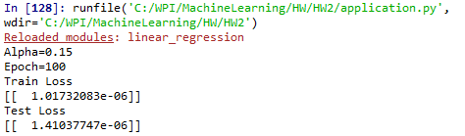

In addition, based on your observations, report a relationship between alpha and number of epochs. Note that a single epoch means the single time you see all examples in the training set.

The figure below is a 3d plot of the train loss as a function of alpha and epoch. As can be observed in the plot, as alpha becomes very small the number of epochs required to achieve a low loss function increases. This makes sense because if the steps are very small(alpha is small) and the number of steps taken(epochs) is small, it’s possible that the minimum will not be achieved.

